SDC Group Meeting – Wednesday 20th April
Discussion:
- Duccio went through the spatial distribution of words superimposed on a map of income by ward in London. The group noted a number of promising spatial trends including thai, chicken, kebab, M&S etc.
- Group then discussed the website design and content.
- Reminded of minimum requirements/content:
  - Interactive visualization
  - Graph of data values
  - Description of Analysis
  - Link to source data
  - Explanation of project
- Marking criteria:
  - Does the project tackle a real world problem? 10%
  - Does the analysis and visualisation tell a compelling story? 30%
  - Have appropriate analysis and visualisation methods been applied to the dataset? 30%
  - Could visualisation/website be published on the web? 10%
  - Design and aesthetics of website 20%
- Decided that a design where the map was the largest item with static content in a vertical bar at the side would be the ‘most modern’ arrangement as below:
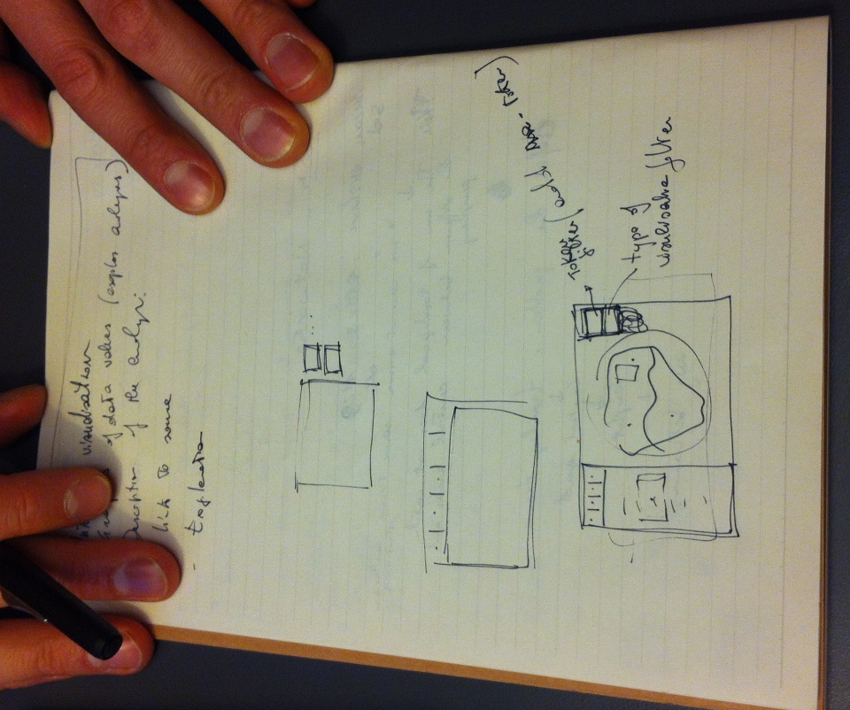

- Decided everyone would likely be busy leading up to assessment, things to start thinking about for each person include:
Jimmy – How to copy data into SQL and start thinking about how to call different words
Duccio – Learning how APIs work
Quiling – Start on HTML structure for the website
Claire – Look at building python functions
Next Meeting: Tuesday May 3rd

